C – Verificación de Condiciones de Bloqueo
Intento 1
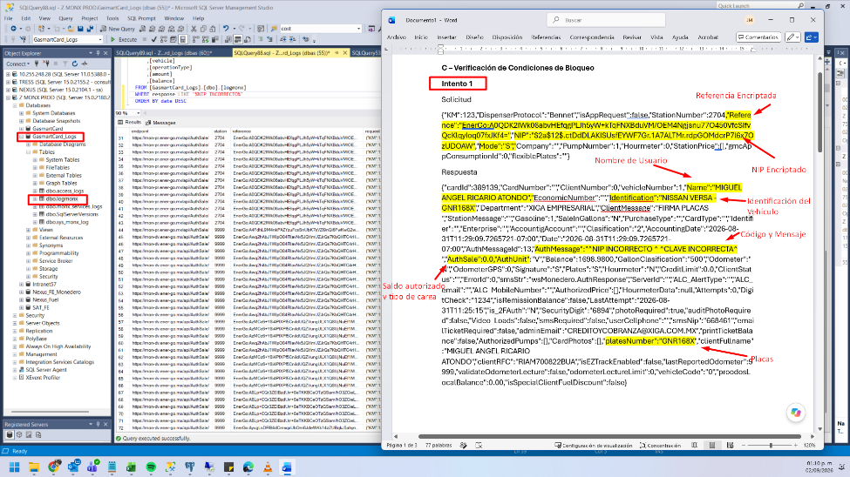
Solicitud
{"KM":123,"DispenserProtocol":"Bennet","isAppRequest":false,"StationNumber":2704,"Reference":"EnerGo:A0QDK2IWk06abvHEfqgPLJh5yW+kTqFNXBduVM/OEM4Ngjsnu77O450VfcSIfvQcKlqyIoq07fxJKf4=","NIP":"$2a$12$.ctDdDLAKISUsfEYWF7Gr.1A7ALTMr.rdpGOMdcrP7l6x7OzUDOAW","Mode":"S","Company":"","PumpNumber":1,"Hourmeter":0,"StationPrice":[],"gmcAppConsumptionId":0,"flexiblePlates":""}
Respuesta
{"cardId":389139,"CardNumber":"","ClientNumber":0,"vehicleNumber":1,"Name":"MIGUEL ANGEL RICARIO ATONDO","EconomicNumber":"","Identification":"NISSAN VERSA -GNR168X","Department":"XIGA EMPRESARIAL","ClientMessage":"FIRMA PLACAS ","StationMessage":"","Gasoline":1,"SaleInGallons":"N","PurchaseType":"","CardType":"","Identifier":"","Enterprise":"","AccountigAccount":"","Clasification":"2","AccountingDate":"2026-08-31T11:29:09.7265721-07:00","Date":"2026-08-31T11:29:09.7265721-07:00","AuthMessageId":13,"AuthMessage":"^NIP INCORRECTO ^ ^CLAVE INCORRECTA^ ","AuthSale":0.0,"AuthUnit":"V","Balance":1698.9800,"GallonClasification":"500","Odometer":"N","OdometerGPS":0,"Signature":"S","Plates":"S","Hourmeter":"N","CreditLimit":0.0,"ClientStatus":"","ErrorId":0,"smsStr":"wsMonedero.AuthResponse","ServerId":"","ALC_AlertType":"","ALC_email":"","ALC_MobileNumber":"","AuthorizedPrice":[],"HourmeterData":null,"Attempts":0,"DigitCheck":"1234","isRemissionBalance":false,"LastAttempt":"2026-08-31T11:25:15","is_2FAuth":"N","SecurityDigit":"6894","photoRequired":true,"auditPhotoRequired":false,"Video_Loads":false,"smsRequired":false,"userCellphone":"","smsNip":"668461","emailTicketRequired":false,"adminEmail":"CREDITOYCOBRANZA@XIGA.COM.MX","printTicketBalance":false,"AuthorizedPumps":[],"CardPhotos":[],"platesNumber":"GNR168X","clientFullname":"MIGUEL ANGEL RICARIO ATONDO","clientRFC":"RIAM700822BUA","isEZTrackEnabled":false,"lastReportedOdometer":9999,"validateOdometerLecture":false,"odometerLectureLimit":0,"vehicleCode":"0","proodosLocalBalance":0.00,"isSpecialClientFuelDiscount":false}
Intento 2
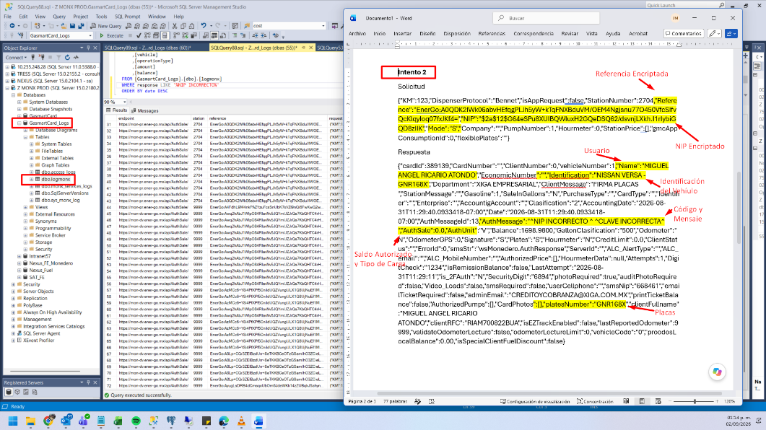
Solicitud
{"KM":123,"DispenserProtocol":"Bennet","isAppRequest":false,"StationNumber":2704,"Reference":"EnerGo:A0QDK2IWk06abvHEfqgPLJh5yW+kTqFNXBduVM/OEM4Ngjsnu77O450VfcSIfvQcKlqyIoq07fxJKf4=","NIP":"$2a$12$G64eSPu8XUIBQWIuxH2GQeDSQ62/dsvnjLXkh.I1rIybiGQD8zIIK","Mode":"S","Company":"","PumpNumber":1,"Hourmeter":0,"StationPrice":[],"gmcAppConsumptionId":0,"flexiblePlates":""}
Respuesta
{"cardId":389139,"CardNumber":"","ClientNumber":0,"vehicleNumber":1,"Name":"MIGUEL ANGEL RICARIO ATONDO","EconomicNumber":"","Identification":"NISSAN VERSA -GNR168X","Department":"XIGA EMPRESARIAL","ClientMessage":"FIRMA PLACAS ","StationMessage":"","Gasoline":1,"SaleInGallons":"N","PurchaseType":"","CardType":"","Identifier":"","Enterprise":"","AccountigAccount":"","Clasification":"2","AccountingDate":"2026-08-31T11:29:40.0933418-07:00","Date":"2026-08-31T11:29:40.0933418-07:00","AuthMessageId":13,"AuthMessage":"^NIP INCORRECTO ^ ^CLAVE INCORRECTA^ ","AuthSale":0.0,"AuthUnit":"V","Balance":1698.9800,"GallonClasification":"500","Odometer":"N","OdometerGPS":0,"Signature":"S","Plates":"S","Hourmeter":"N","CreditLimit":0.0,"ClientStatus":"","ErrorId":0,"smsStr":"wsMonedero.AuthResponse","ServerId":"","ALC_AlertType":"","ALC_email":"","ALC_MobileNumber":"","AuthorizedPrice":[],"HourmeterData":null,"Attempts":1,"DigitCheck":"1234","isRemissionBalance":false,"LastAttempt":"2026-08-31T11:29:11","is_2FAuth":"N","SecurityDigit":"6894","photoRequired":true,"auditPhotoRequired":false,"Video_Loads":false,"smsRequired":false,"userCellphone":"","smsNip":"668461","emailTicketRequired":false,"adminEmail":"CREDITOYCOBRANZA@XIGA.COM.MX","printTicketBalance":false,"AuthorizedPumps":[],"CardPhotos":[],"platesNumber":"GNR168X","clientFullname":"MIGUEL ANGEL RICARIO ATONDO","clientRFC":"RIAM700822BUA","isEZTrackEnabled":false,"lastReportedOdometer":9999,"validateOdometerLecture":false,"odometerLectureLimit":0,"vehicleCode":"0","proodosLocalBalance":0.00,"isSpecialClientFuelDiscount":false}
Intento 3 y bloqueo
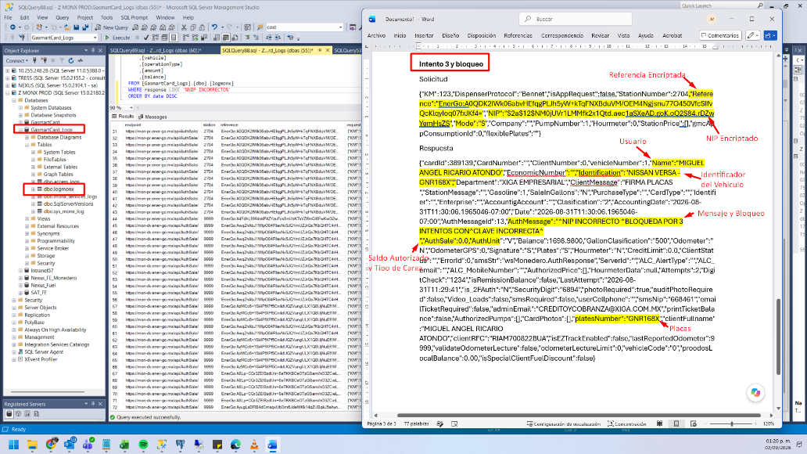
Solicitud
{"KM":123,"DispenserProtocol":"Bennet","isAppRequest":false,"StationNumber":2704,"Reference":"EnerGo:A0QDK2IWk06abvHEfqgPLJh5yW+kTqFNXBduVM/OEM4Ngjsnu77O450VfcSIfvQcKlqyIoq07fxJKf4=","NIP":"$2a$12$NM0jUVr1LMMfk2x1Qtd.aec1aSXeAD.goK.oQ2S84.rDZwYemHsZS","Mode":"S","Company":"","PumpNumber":1,"Hourmeter":0,"StationPrice":[],"gmcAppConsumptionId":0,"flexiblePlates":""}
Respuesta
{"cardId":389139,"CardNumber":"","ClientNumber":0,"vehicleNumber":1,"Name":"MIGUEL ANGEL RICARIO ATONDO","EconomicNumber":"","Identification":"NISSAN VERSA -GNR168X","Department":"XIGA EMPRESARIAL","ClientMessage":"FIRMA PLACAS ","StationMessage":"","Gasoline":1,"SaleInGallons":"N","PurchaseType":"","CardType":"","Identifier":"","Enterprise":"","AccountigAccount":"","Clasification":"2","AccountingDate":"2026-08-31T11:30:06.1965046-07:00","Date":"2026-08-31T11:30:06.1965046-07:00","AuthMessageId":13,"AuthMessage":"^NIP INCORRECTO ^BLOQUEDA POR 3 INTENTOS CON^CLAVE INCORRECTA^ ","AuthSale":0.0,"AuthUnit":"V","Balance":1698.9800,"GallonClasification":"500","Odometer":"N","OdometerGPS":0,"Signature":"S","Plates":"S","Hourmeter":"N","CreditLimit":0.0,"ClientStatus":"","ErrorId":0,"smsStr":"wsMonedero.AuthResponse","ServerId":"","ALC_AlertType":"","ALC_email":"","ALC_MobileNumber":"","AuthorizedPrice":[],"HourmeterData":null,"Attempts":2,"DigitCheck":"1234","isRemissionBalance":false,"LastAttempt":"2026-08-31T11:29:41","is_2FAuth":"N","SecurityDigit":"6894","photoRequired":true,"auditPhotoRequired":false,"Video_Loads":false,"smsRequired":false,"userCellphone":"","smsNip":"668461","emailTicketRequired":false,"adminEmail":"CREDITOYCOBRANZA@XIGA.COM.MX","printTicketBalance":false,"AuthorizedPumps":[],"CardPhotos":[],"platesNumber":"GNR168X","clientFullname":"MIGUEL ANGEL RICARIO ATONDO","clientRFC":"RIAM700822BUA","isEZTrackEnabled":false,"lastReportedOdometer":9999,"validateOdometerLecture":false,"odometerLectureLimit":0,"vehicleCode":"0","proodosLocalBalance":0.00,"isSpecialClientFuelDiscount":false}

